**Ülesanne 12**

**-----------------------------**

.open moell.db

CREATE TABLE kasutajad(

id INTEGER PRIMARY KEY AUTOINCREMENT,

eesnimi TEXT NOT NULL,

perenimi REAL NOT NULL,

email REAL NOT NULL,

tel REAL NOT NULL

);

ALTER TABLE kasutajad RENAME TO users;

ALTER TABLE users RENAME COLUMN tel TO ifoon;

.schema users

ALTER TABLE users ADD COLUMN image TEXT;

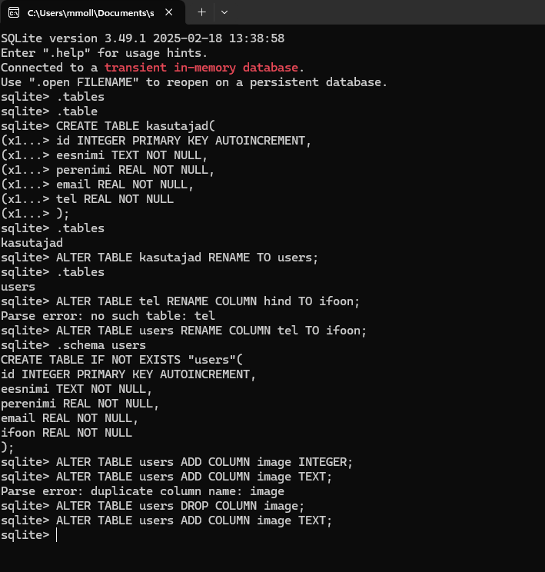

**Ülesanne 13**

**-----------------------------**

INSERT INTO users (eesnimi, perenimi, email, ifoon, image) VALUES

('Imre', 'Tard', 'Tard.Imre@gmail.com', '5555555', 'retard.png'),

('Karin', 'Eegreid', 'Eegreid.Karin@gmail.com', '5555556', 'KKK.png');

SELECT * FROM users;

.read userpdx.sql

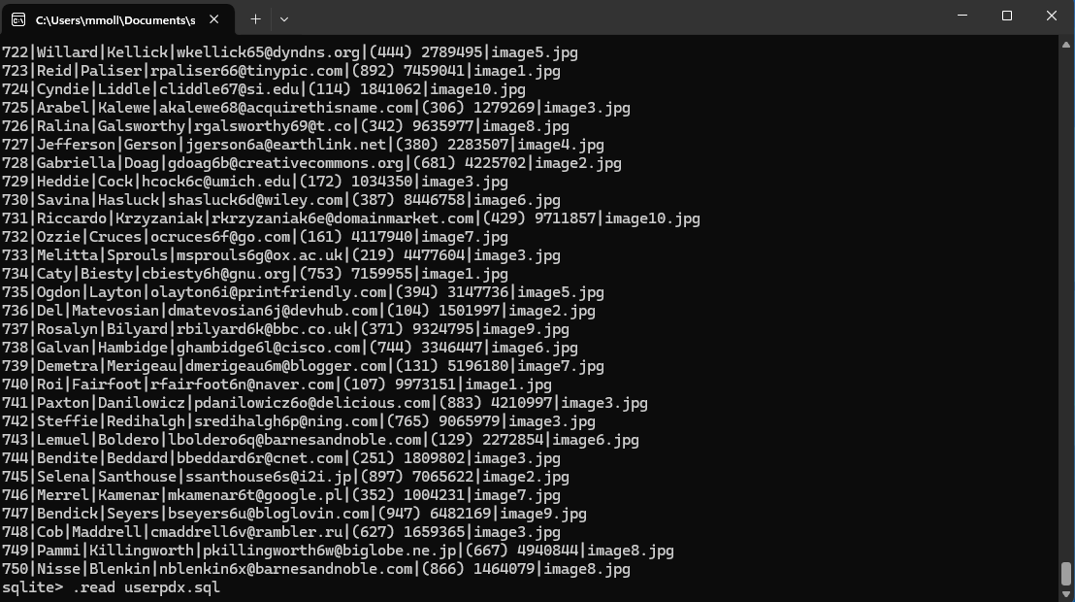

**Ülesanne 14**

**-----------------------------**

SELECT * FROM users ORDER BY perenimi ASC LIMIT 3;

SELECT * FROM users WHERE eesnimi LIKE 'G%';

SELECT * FROM users WHERE email LIKE '%.com';

SELECT * FROM users ORDER BY email DESC;

SELECT * FROM users WHERE ifoon LIKE '(372)%';

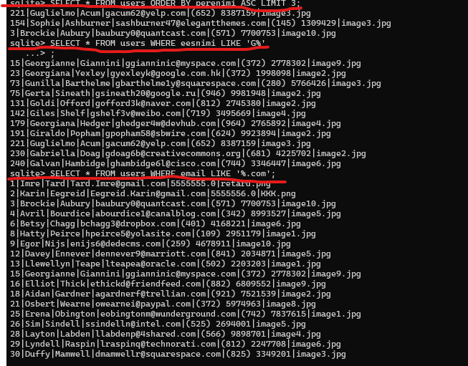

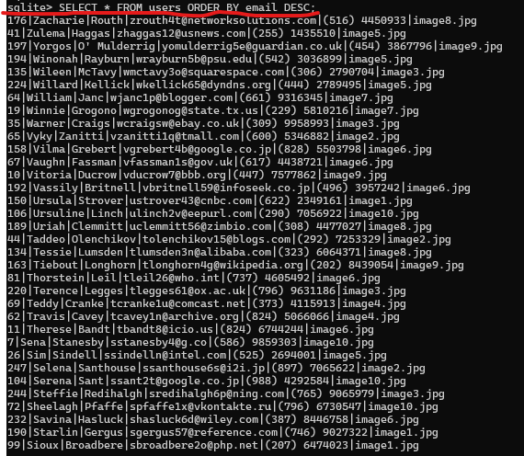

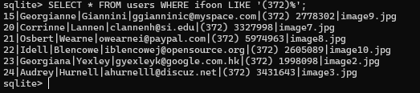

**Ülesanne 15**

**-----------------------------**

UPDATE users

SET email = 'muudetud@gmail.com', ifoon = '123'

WHERE eesnimi = 'Mathias';

DELETE FROM users

WHERE id BETWEEN 5 AND 10;

SELECT * FROM users

ORDER BY id ASC

LIMIT 10;

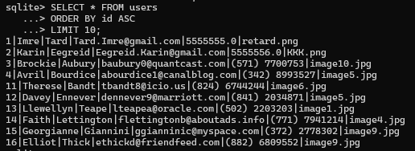

**Ülesanne 16**

**-----------------------------**

CREATE TABLE kursused (

id INTEGER PRIMARY KEY AUTOINCREMENT,

nimi TEXT NOT NULL,

opetaja_id INTEGER );

INSERT INTO kursused (nimi, opetaja_id) VALUES

('Andmebaasid', 1),

('Python', 2);

SELECT * FROM kursused;

CREATE TABLE registreerimised (

id INTEGER PRIMARY KEY AUTOINCREMENT,

kasutaja_id INTEGER,

kursus_id INTEGER );

INSERT INTO registreerimised (kasutaja_id, kursus_id) VALUES

(1, 1),

(2, 2);

SELECT * FROM registreerimised;

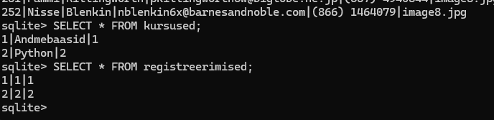

**Ülesanne 17**

**-----------------------------**

SELECT kursus_id, COUNT(kasutaja_id) AS registreerimised

FROM registreerimised

GROUP BY kursus_id

ORDER BY registreerimised DESC

LIMIT 1;

**Ülesanne 18**

**-----------------------------**

